Friendship Fundamentals: Social Skills Group Counseling

Bailey Lowenthal

Harvard Graduate School of Education

Abstract

“Friendship Fundamentals” is a group counseling program focused on improving the social skills of middle school students who have Autism Spectrum Disorders (ASD). The group will have a maximum of 6-8 members, including typically developing peers and will meet once a week for 60 minutes for a minimum of 12 weeks. Members will be high functioning and the group will be heterogeneous in race, socio-economic status and family background. Teachers will be integral in the recruitment of group members and all participants will ­­go through a screening process before the beginning of group. Middle school is a time of heightened social pressure (Benner, 2011) and due to their “persistent deficits in social” skills students with ASD have a particularly hard time during these years (Adreon & Stella, 2001; American Psychiatric Association, 2013, p. 299). Fortunately, many studies show that group counseling is an effective way to increase social skills for individuals with ASD (Carter et al., 2004; Leaf et al., 2012). “Friendship Fundamentals’” sessions will cover topics such as engaging in reciprocal conversation, understanding the implicit rules of friendship, identifying the correlation between emotions and body language, starting a conversation, understanding theory of mind and active listening. The overarching goal of the group is to improve members’ social-emotional reciprocity, comprehension of nonverbal communicative behaviors, and understanding of what it takes to develop and maintain relationships. Achievement of group and individual goals will be assessed using quantitative and qualitative measures, including input from students, group facilitators, teachers and parents.

Autism Spectrum Disorder (ASD) is a term that covers “a group of complex disorders of brain development” (Autism Speaks Inc, 2013). It is a “logical truism and empirical fact” that individuals with Autism Spectrum Disorders (ASD) have trouble with social skills and in social relationships (McConnell, 2002, p. 351). These deficits make the transition to middle school and adolescence a trying time for youth with ASD and are associated with negative “psychological adjustment…academic outcomes, and perceptions of competency” (Adreon & Stella, 2001, p. 266). Additionally, problems with social skills may contribute to the development of long term “clinical problems such as anxiety, depression, and or other behavioral disorders” (Elder et al., 2006, p. 635). Fortunately, research shows that group interventions can improve social skills use for young people with ASD (Cotugno, 2009; MacKay, Knott, and Dunlop, 2007; Longhurt et al., 2010). Consequently, “Friendship Fundamentals,” a group counseling intervention, focuses on improving the social skills of middle school students with ASD.

This paper will describe in detail the group counseling intervention “Friendship Fundamentals.” As a starting point a definition and prevalence rates of Autism Spectrum Disorders (ASD) are provided. Then this writer details the population make-up of the group, the group structure, as well as recruiting and screening strategies. Next, current literature concerning ASD and social skills deficits is covered and the validity of utilizing group counseling as a treatment for this population and problem is assessed. Then, the writer presents a brief synopsis of six sample sessions. Finally the author reviews the overall purpose and concrete sub-goals of the intervention along with assessment tools.

**Population**

“Autism Spectrum Disorders (ASD) are neurological disorders” that affect “an individual’s social interaction, language and communication, and behavioral range of activities and interests” (Cotungo, 2009, p. 1268). While the cause of ASD is still unknown, it is thought that ASD develops very early in brain development but normally obvious signs and symptoms are noticed between 2 and 3 years of age (Autism Speaks Inc, 2013). According to the Center for Disease Control (2013) ASD occurs in about 1 in 88 children. People with ASD have difficulties with social interactions, communication, and behavior (American Psychiatric Association, 2013). For the purposes of this group the population will be high functioning middle school students with ASD, inclusive of one or two typically developing peers who will serve as group models. Research shows that inclusion of these peers helps students with ASD generalize their skills to real life situations and increases acceptance of students with ASD among their peer group (MacKay, Knott & Dunlop, 2007; White, 2010). Additionally, the group will consist of female and male students in 6th to 8th grade and will be heterogeneous in race, socio-economic status and family background. The following sections describe in detail the reasoning behind the selection of this specific population.

Students with high functioning ASD are more acutely aware of their social deficits than other individuals with ASD (White et al., 2010). This awareness can produce more negative outcomes for this subset of the population (White et al., 2010). It has also been proven that high functioning individuals with ASD benefit the most from the group counseling approach to social skills remediation (Reichow & Volkmar, 2010).

Middle school is a critical time of social growth for all individuals (Benner, 2011; Kennelly & Monrad, 2007). Many school districts have transition periods during this time, from elementary school and to high school. These transitions negatively effect most students but are specifically difficult for students with ASD due to their dislike of change and affinity for repetition (Adreon & Stella, 2001). By increasing members’ social skills at such a critical period in their educational journey it is hoped that they will gain friends and skills in the group that will help them in middle school and prepare them to enter high school with a social tool box in hand.

ASD can affect all children regardless of race, socio-economic status or familial background. Heterogeneity in background will help students interact with individuals who may differ from them in terms of social norms and responses. Similarly, generally males and females have different ways of socializing and it is important for individuals to attempt to understand and incorporate different communication styles. This will enable students to more readily generalize the skills they learn in group to the larger world around them.

**Group Structure**

“Friendship Fundamentals” is a remedial group because students with ASD generally have social skills deficits. Therefore, this group will focus on correcting or at least ameliorating this deficit. The group will include up to 6 members, exclusive of peer models. If more than 6 students with ASD wish to partake in the group then two groups will be arranged. It is important to keep the groups relatively small in accordance with Greenberg’s (2003) suggestion that 6-8 students be involved in a middle school group, especially due to the developmental deficits that regularly effect students with ASD. In accordance with research on effectiveness of group interventions, the group will run for a minimum of twelve weeks, with an ideal format being a yearlong intervention (Bellini et al, 2007). The group would meet once a week for 60 minutes, possibly during a built in study period or elective. This will be a closed group in that only students with a diagnosis of ASD or peer models will be allowed to join. Parents, teachers and staff will refer students.

**Recruiting**

Recruiting for this group will take a two-pronged approach. First, teachers will refer students with ASD who they perceived are having difficulty socializing with others based on classroom observations. Teachers will look for behaviors such as students not making appropriate eye contact, not approaching other students to engage in social interactions, or the lack of the student’s use of reciprocal communication. Teachers are in the best position at the school to evaluate these skills because they see students’ use, or lack of use, of social skills every day. All teachers of students with high functioning ASD will be emailed a Google survey where they can nominate students to partake in the group. Teachers know that students have ASD because it is in the student’s individual education plan. Once they nominate the student they will be asked to complete a survey on the social skills they observe the student use in their classroom (See Appendix C). Meetings with the teacher to discuss individual students may also occur. This same strategy will be utilized to select peer models, with the exception that teachers will nominate students who display exceptional social skills and respectful interaction with students with disabilities.

Secondly, if parents feel like their children can benefit from a social skills group they should have the option of nominating their child for the group. Parent involvement and engagement is critical. A month before the group starts parents of high functioning students with ASD will be mailed a letter, sent an email, or called at home to notify them about the existence of the group and given the option to ask that their student be considered for participation. Similar to teacher referrals, parents will be asked to fill out a survey about their child’s social interactions. Individual conversations will also take place via phone.

**Screening Interview**

Students will be interviewed before they are selected for group participation. For this specific group students will have to display a moderate level of verbal functioning. If a student is preverbal or unwilling to communicate in a group this may not be the right intervention for them. The interview will also assess cognitive functioning. As previously stated social skills groups will be most effective for students how are high functioning. They will need to demonstrate that they can ask and answer simple questions, formulate new sentences, etc. Also, students must have an awareness of others. If students are not even aware of others in the room this will not be an appropriate intervention. Student do not need to posses a full understanding of theory of mind as this is a hard concept for many students with ASD to grasp but they must be able to understand the fact that other people feel differently than they do and can have different thoughts. However, they are not required to accurately predict what those feelings or thoughts are as this will be one of the topics covered in group. Additionally, students must be able to name and label basic emotions. While the group will focus on identifying feelings and emotions students should have a basic concept of what makes them mad, sad and happy. Finally, students should have at least 4th grade writing and reading skills because some of the group work may require journaling, group reading and some writing (pictures will be allowed as substitution when feasible). As for the typically developing peer models, additional requirements such as outstanding social skills and the ability and desire to interact respectfully with students who have ASD will be assessed in the interview.

**ASD and Social Skills Deficits: A Literature Review**

The first diagnostic criteria for ASD in the Diagnostic and Statistical Manual V is “persistent deficits in social communication and social interaction across multiple contexts” specifically deficits in “social-emotional reciprocity… nonverbal communicative behaviors… [and] developing, maintaining and understanding relationships” (American Psychiatric Association, 2013, p. 299).When compared to their typically developing peers, children with ASD “spent less time in proximity to others… received fewer social initiations…were less likely to focus on other children [and] produced fewer verbalizations…” (McConnell, 2002, p. 354).According to Elder and colleagues (2006) individuals with ASD have trouble with the concept of theory of mind, meaning they don’t understand that others have different “feelings, thoughts, need or intentions” (p. 640). Thus individuals with ASD can appear selfish or insensitive to their peers and frequently feel socially isolated (Elder et al., 2006).

**Transition Periods Exacerbate Deficits**

The transition to and from middle school is hard for all students (Benner, 2011; Kennelly & Monrad, 2007). In general, students experience increases in depression, anxiety, criminal activity, drug abuse and depression as well as decreased academic performance, school engagement and self-esteem (Benner, 2011; Vanlede, Little & Card, 2006). In addition to many other transition factors, increases in expectations for behavior, complex peer relationships, and social conformity create a stressful environment that can negatively affect students with ASD (Adreon & Stella, 2001).For high-functioning teens with ASD their social disability may be felt more in adolescence because they become more aware of their deficits as “the social milieu becomes more complex” (White et al., 2010b, p. 78). Due to their inability to achieve social expectations, students with ASD are at higher risk for mood and anxiety disorders and “experience significant problems in adjustment, achievement, aspirations and feelings of self-worth” (Adreon & Stella, 2001, p. 267; White et al., 2010b). Additionally, during middle school the social gap between students with ASD and their typically developing peers may widen (Thiemann-Bourque, 2010). Particularly during middle school, children with ASD are frequently “excluded, teased or bullied” and might start to “feel left out, misunderstood, or persecuted” (Ardeon & Stella, 2001, p. 268). It is because of these reasons that the group counseling intervention described in this paper will target middle school students.

**Negative Consequences of Social Skills Deficits For Youth with ASD**

The consequences of poor social skills and lack of developmentally appropriate relationships can have devastating long-term effects on young people with ASD. In a survey of over 400 youth with ASD and their parents, a 94% prevalence rate of peer victimization was reported and “peer shunning was common” (Little, 2001, p. 995). Elder and collogues (2006) state that children or adolescents who are “poorly accepted by peers” have a higher likelihood of “school maladjustment, delinquency, child psychopathology, and adult mental health difficulties” (p. 646). Multiple studies have found that social skill deficits are significantly associated with depression (Imazu, 2005; Segrin, 1990; Ross, Shochet, & Bellair, 2010). Difficulty with social skills can also lead to poor academic achievement or substance abuse (Bellini et al., 2007). Hagopian, Kuhn, and Strother (2009) assert that these deficits put youth with ASD “at higher risk for developing problem behavior” such as self-injury or aggression (p. 907; Elder et al, 2006). Furthermore, it has been theorized that social deficits can produce high levels of anxiety for youth with ASD, especially for higher functioning young people “who have an awareness of their social disability” (White et al., 2010, p. 1006). Such negative and long lasting consequences clearly illustrate why programs are needed to help young people with ASD improve their social skills.

**Effectiveness of Social Skills Group Counseling for Students with ASD**

Many studies have proven that group counseling is an effective way to improve this population’s social skills (MacKay, Knott & Dunlop, 2007; Carter et al., 2004; Leaf et al., 2012).Group counseling provides many teens with ASD the first opportunity to experience “social acceptance in a peer group,” which, even by itself, can create change in sociability (White, 2010, p. 81).MacKay, Knott, and Dunlop (2007) ran a “groupwork” intervention for 46 students with ASD that met weekly for 90 minutes over 12-16 weeks (p. 279). The authors focused on increasing “social and emotional perspective-taking…conversation skills…and friendship skills” through “games, group discussion, role play and independent choice” (MacKay, Knott & Dunlop, 2007, p. 282). They were sure to include activities such as taking field trips, riding busses, going bowling and eating meals together, which enabled students to generalize skills from group into real life situations (MacKay, Knott & Dunlop, 2007). Using the responses from four empirically validated questionnaires participants showed improvement in target areas (MacKay, Knott & Dunlop, 2007).

Another study that used a group format to enhance social skills for students with ASD is reviewed in Cotugno’s (2009) paper. Cotugno (2009) studied a group that consisted of 7-11 year old children with ASD and met 1 hour a week for 30 weeks. The group focused on “social competence and social skills” and used a “cognitive-developmental framework” combining cognitive-behavior and skill instruction (Cotugno, 2009, p. 1270). The intervention group demonstrated “significant gains” as shown on two validated social scales (Cotugno, 2009, p. 1277). Furthermore, Longhurst and colleagues (2010) ran a group within an alternative school context for students with Asperger’ syndrome, now known as ASD. The group met 5 times a week and utilized a “Positive Peer Culture” format[1] (p. 41). Longhurt (2010) found that counseling can significantly improve student’s “ability to develop, maintain and value their relationships with peers, family members, teachers and others” (p. 44). In this current educational climate, which focuses on evidence based practices, it is important to note that in a meta analysis of 66 studies focused on social skills interventions of people with autism Reichow and Volkmar (2010) discovered that social skills groups were one of only two intervention types that could be considered an evidence-based practice. Specifically, social skills groups were most effective with participants who had *“*medium and high levels of cognitive functioning,” were middle to high school aged, and when sessions were held for an extended period of time (Bellini et al, 2007; Reichow & Volkmar, 2010, p. 160).

**Group Sessions**

As noted in the research above due to the severity of social skills deficits in youth with ASD ideally “Friendship Fundamentals" would run for the entire school year (Bellini et al, 2007). However, due to the practicalities and constraints of running a group during the school day this is not often feasible. For social skills group counseling to be effective with this population research suggests that sessions run for at least 12 weeks (Bellini et al, 2007). Appendix A details six of the group sessions in “Friendship Fundamentals.” “Getting started,” outlines the first session of the group. “Reciprocal Conversation” represents a lesson that should be at the beginning of the group sessions but does not need to be the second session. Before moving to the rest of the lessons students will set personal goals for group, the lesson plan for this is not included in the appendix but many check-ins will focus on individual progress towards personal goal achievement. “Staying On Topic” and “Listening to Others” are lessons that would be appropriate for the group in the working stage. “Understanding Body Language Part 2” must be preceded by a lesson that introduces members to the idea of theory of mind as well as the concept of body language in general. Finally, “Termination” is an outline of the final session of the group.

**Purpose and Goals**

The umbrella purpose of this group is to increase participants’ social-emotional reciprocity, understanding of nonverbal communicative behaviors, and understanding what it takes to develop and maintain relationships. Achievement of this purpose will be measured using several concrete and tangible goals. By the end of group 60% of participants will be able to engage in reciprocal conversation on a familiar topic and stay on a common topic for at least six exchanges. These goals will be evaluated using an exit interview performed after group termination by the group leader. For example, the interviewer will engage in a one-on-one conversation with the group participant about a common topic, such as a class assignment, and the student will be able to have a back-and-forth conversation for at least six exchanges (See Appendix B for sample interview and responses).

Additionally, 75% of participants will be able to identify at least five common facial expressions and their corresponding emotions, demonstrate understanding of the meaning behind at least five common idioms and list at least five qualities of being a good friend. These goals will be evaluated using a written or verbal survey. Students will be given a survey with five pictures of children making various faces and be asked to describe or write how they think the child is feeling based on their body language. Students will be given written examples of common idioms such as “he was caught red handed” with context clues and be asked to rewrite or retell the idiom in their own words. These idioms and how to use context clues will be covered directly in group sessions. Additionally, students will be asked to list five qualities of being a good friend, which again will be covered directly in group sessions. For more detailed examples of the student assessment materials see Appendix C.

Additionally, teachers will fill out the TRIAD Social Skills Survey for teachers pre and post group (see Appendix D). A goal for the group will be for teachers to rate increases in at least two of the following for 50% or more of the participants; student’s ability to initiate social interactions (Questions 18, 19, 20, 23, 29, 30; increase=3 points total), understand theory of mind (Questions 14, 15, 16, 46; increase = 2 points total), give compliments (Question 28; increase =1 point total), respond appropriately in social interactions (Questions 29-33, 48 increase =3 points total), and make eye contact and smile at others (Questions 41, 43, 50; increase =1.5 points total). Instead of giving an abridged version of the survey, which would only focus on the target behaviors, it is imperative that the full survey be used to determine the full scope of the intervention’s effect on participants’ social skills. This survey includes both quantitative and qualitative questions. Finally, parents will indicate a qualitative improvement in student’s social abilities as demonstrated in comments made by parents in post group interviews (see Appendix E).

**Conclusion**

“Friendship Fundamentals” is a group counseling intervention focused on improving middle school students with ASD’s social competence. Group sessions cover aspects of social interactions that the DSM 5 has identified as particularly troublesome for individuals with ASD (American Psychiatric Association, 2013). The group, inclusive of a typically developing peer, allows members to practice social skills in a controlled context while homework assignments improve generalization of these skills. After participating in “Friendship Fundamentals” participants will demonstrate increased ability in engaging in appropriate social interactions, thus ameliorating the negative consequences of social deficits.

References

American Psychiatric Association. (2013). *Diagnostic and statistical manual of mental disorders* (5th ed.). Arlington, VA: American Psychiatric Publishing.

Autism Speaks Inc., (2013). *What is Autism?* Retrieved from http://www.autismspeaks.org/what-autism

Adreon, D., & Stella, J. (2001). Transition to Middle and High School Increasing the Success of Students with Asperger Syndrome. *Intervention in School and Clinic*, *36*(5), 266-271.

Barnhill, G. P., Cook, K. T., Tebbenkamp, K., & Myles, B. S. (2002). The effectiveness of social skills intervention targeting nonverbal communication for adolescents with Asperger syndrome and related pervasive developmental delays. *Focus on Autism and Other Developmental Disabilities*, *17*(2), 112-118.

Barry, T. D., Klinger, L. G., Lee, J. M., Palardy, N. Gilmore, T., & Bodin, S. D. (2003). Examining the effectiveness of an outpatient clin- ic-based social skills group for high-functioning children with autism, *journal of Autism and Developmental Disorders,* 33(6), 685-701.

Bellini, S., Peters, J. K., Benner, L., & Hopf, A. (2007). A meta-analysis of school-based social skills interventions for children with autism spectrum disorders. *Remedial and Special Education*, *28*(3), 153-162.

Benner, A. D. (2011). The transition to high school: Current knowledge, future directions. *Educational psychology review*, *23*(3), 299-328.

Carter, C, Meckes, L., Pritchard, L., Swensen, S. Wittman, P. P , & Vel- de, B. (2004). The friendship club: An after-school program for children with Asperger syndrome. *Family and Community Health,* 27(2), 143-150.

Center for Disease Control. (2013) *Autism Spectrum Disorder, Data and Statistics*. Retrieved from http://www.cdc.gov/ncbddd/autism/data.html

Cotugno, A. J. (2009). Social competence and social skills training and intervention for children with autism spectrum disorders. *Journal of autism and developmental disorders*, *39*(9), 1268-1277.

Elder, L. M., Caterino, L. C., Chao, J., Shaknai, D., & De Simone, G. (2006). The Efficacy of Social Skills Treatment for Children with Asperger Syndrome. *Education and Treatment of Children*, *29*(4), 635-663.

Imazu, Y. (2005). Social skill deficits and depression in junior high school girls. *Japanese Journal Of Psychology*, *76*(5), 474-479.

Kennelly, L., & Monrad, M. (2007). *Easing the Transition to High School: Research and Best Practices Designed to Support High School Learning*. National High School Center.

Kim, J., The collective mental archives of the H340 Teaching Team. (2013). *H340 Section*

*Facilitation Handout.* Unpublished Course Document.

Kransy, L., Williams, B. J., Provencal, S., & Ozonoff, S. (2003). Social skills interventions for the Autism Spectrum: Essential ingre- dients and a model curriculum. *Child and Adolescent Psychiat- ric Clinics of North American,* 22(1), 107-122.

Leaf, J. B., Dotson, W. H., Oppenheim-Leaf, M. L., Sherman, J. A., & Sheldon, J. B. (2012). A Programmatic Description of a Social Skills Group for Young Children With Autism. *Topics in Early Childhood Special Education*, *32*(2), 111-121.

Little, L. (2001). Peer victimization of children with Asperger spectrum disorders. *Journal Of The American Academy Of Child & Adolescent Psychiatry*, *40*(9), 995-996.

Longhurst, J., Richards, D., Copenhaver, J., & Morrow, D. (2010). " Outside In": Group Treatment of Youth with Asperger's. *Reclaiming Children and Youth*, *19*(3), 40-44.

MacKay, T., Knott, F., & Dunlop, A. W. (2007). Developing social interaction and understanding in individuals with autism spectrum disorder: A groupwork intervention. *Journal of Intellectual and Developmental Disability*, *32*(4), 279-290.

McConnell, S. R. (2002). Interventions to facilitate social interaction for young children with autism: Review of available research and recommendations for educational intervention and future research. *Journal of autism and developmental disorders*, *32*(5), 351-372.

Ross, A. G., Shochet, I. M., & Bellair, R. (2010). The Role of Social Skills and School Connectedness in Preadolescent Depressive Symptoms. *Journal Of Clinical Child & Adolescent Psychology*, *39*(2), 269-275.

Segrin, C. (1990). A meta-analytic review of social skill deficits in depression. *Communication Monographs*, *57*(4), 292-308.

Smead, R. (2000). *Skills for Living: Group Counseling Activities for Young Adolescents.* Champaign, IL: Research Press.

Vanlede, M., Little, T. D., & Card, N. A. (2006). Action-control beliefs and behaviors as predictors of change in adjustment across the transition to middle school. Anxiety, stress, and coping, 19(2), 111-127.

White, S. W., Albano, A. M., Johnson, C. R., Kasari, C., Ollendick, T., Klin, A., & Scahill, L. (2010). Development of a cognitive-behavioral intervention program to treat anxiety and social deficits in teens with high-functioning autism. *Clinical child and family psychology review*, *13*(1), 77-90.

White, S. W., Koenig, K., & Scahill, L. (2010b). Group social skills instruction for adolescents with high-functioning autism spectrum disorders. *Focus on Autism and Other Developmental Disabilities*, *25*(4), 209-219.

White, S. W., & Roberson-Nay, R. (2009). Anxiety, social deficits, and loneliness in youth with autism spectrum disorders. *Journal of Autism and Developmental Disorders*, *39*(7), 1006-1013.

Appendix A Group Sessions

**Getting Started**

**Source:**

Smead, R. (2000). *Skills for Living: Group Counseling Activities for Young Adolescents.* Champaign, IL: Research Press.

Kim, J, The collective mental archives of the H340 Teaching Team. (2013). *H340 Section Facilitation Handout.* Unpublished Course Document.

**Target population/Issue:**

* Middle School Students with ASD/Social Skills Deficits
* In initial stages of a group/Session on getting started

**Outline of the Activity:**

* Welcome to group!
* **Ice-breaker**: Picnic Name Game
* **Introduction**: Philosophy and goals of group
  + This group will help them deal with some of the difficulties they may be having with relationships.
  + Explain how ASD effects relationships building (see Literature Review)
  + Give a routine-every week for 45 minutes and focus on helping members with social skills (Define social skills)
* **Set confidentiality and norms**
  + State confidentiality rules. What’s said in group stays in group. The only exceptions are if members express that they intend to hurt themselves or others and if someone is hurting them. (Check comprehension if needed by asking, “What are examples of when I would have to break confidentiality?”)
    - Discuss what the group would like to do if members break confidentiality.
    - Give examples of answers to common questions that others might ask.
    - Example-What do you talk about in group anyway? Ask members how they should respond without breaking confidentiality (we talk about life and relationships).
  + Hand out group folders, explain that these folders will be where group members can store their completed activities from group.
  + Set norms: ask questions like “What are some rules that will help you feel comfortable sharing your thoughts and feelings in group?” Try to limit to 5 norms. Write group responses on a large sheet of paper and have members sign their name at the bottom. Have members write the group norms on the back of their folders.
* **Discussion Questions**
  + Any questions/reactions to what we’ve discussed so far?
* **Folder Decoration** 
  + Bring out magazines, markers and glue sticks. Have members decorate the front of their folder with pictures/poems/magazine cut outs/etc. that represent themselves and their lives (Example: draw a picture of a Chihuahua if you have or like Chihuahuas, cut out a picture of your favorite entertainer, write a poem about your life, etc.)
  + Have members share their creation with the group.
* **Process Questions** 
  + What was this first session like for you?
  + How did it feel to share your folders decorations with the group?
  + “When we came in today, we were not a group, just 7 individuals sitting down together. Now we have begun to do things together and get to know one another. How are you feeling right now about being a group member?” (Smead, 2000, p. 126)
* **Wrap Up**
  + “Thank members for their sharing” (Kim et al., 2013).
  + Summarize session, example: Today in group we talked about the purpose of group, established group norms and talked about confidentiality. Then we got to know a little bit more about each other through our folder collages. -Be sure to point out specific themes that occurred or salient points that were made by participants.

**Rationale:**

* “Setting norms, expectations and structure is an important aspect of starting any group. By beginning this way, the groundwork will be laid for a cohesive group,” (Kim et al., 2013).

**Goals:**

* “To facilitate trust-building in group by explicit norm-setting” (Kim et al., 2013).
* “To explain goals, expectations and structure of sessions” (Kim et al., 2013).
* “To begin the practice of sharing stage-appropriate disclosures through” personal collages (Kim et al., 2013).

Instructions for Picnic Name Game

Tell students you are going on an imaginary picnic. Ask the students to go around the room introducing themselves by saying their names and a food to bring that begins with the first letter of the name. (I’m Sarah and I’m bringing sandwiches.) The next person must give the names and foods of everyone who came before, then his/her own name. Instructors usually go last, so that they have to repeat everyone’s name.

**Reciprocal Conversation**

**Source:**

do 2 learn. (2009). *Reciprocal Conversation.* Retrieved from

<http://www.do2learn.com/organizationtools/SocialSkillsToolbox/ReciprocalConversation.htm>

**Target population/Issue:**

* Middle School Students with ASD/Social Skills Deficits
* Initial stages of group

**Outline of the Activity:**

* **Ice breaker:** People Bingo
* **Review of norms** **& previous session**
  + Make sure everyone is still comfortable with norms and there are no additions or confusions.
* **Activities**
  + Read Participating in Reciprocal Conversation Article
    - *Discussion questions*: How is having a conversation like playing a game of catch? When someone is speaking what should the other person be doing?
  + Explain: You are going to practice a reciprocal conversation with a partner. I have random topics in a hat and I will pick one. Each pair will receive a ball and whoever is holding the ball will make a comment on the topic and then throw the ball *softly* to their partner, the partner will then say something in return to their partner about the same topic and throw the ball. Each pair will stay on the topic for at least three throws.”
  + Model this concept with a member.
  + Example topics: Movies, restaurants, favorite place to be, what you do in your free time, songs/musicians, what you want most out of this group, hobbies, etc.
  + Group members participate in reciprocal conversation activity.
* **Process Questions**
  + What was the activity like for you?
  + By a show of thumbs (up, down, middle) was the activity easy for you? Up-yes, Down-no, Middle- kind of. [member name] why was this easy/hard? [member name] what part was easy/hard?
  + How did it feel to have to say something in response to someone?
  + Who felt it was hard to listen to your partner? [answer] Why or at what times?
  + Which topic was the easiest to talk about?
  + How does this connect to real life social situations?
* **Wrap Up:** Thank members for their participation and engagement
  + Today we got to know each other a little better by playing people bingo and having conversations. We learned how to have a conversation about the same topic and take turns talking. -Be sure to point out specific themes that occurred or salient points that were made by participants.
  + Optional Homework: Write down one reciprocal conversation you have in the next week and come to group ready to share about your experience.

**Rationale:**

* Getting to know you activities allow group members to becoming comfortable and lay the groundwork for the formation of a group identity.
* Youth with ASD have a hard time understanding the reciprocal nature of conversations. By explicitly stating this norm, modeling it and allowing members to practice it members can improve in this social skill. Additionally, using the suggested topics will help members get to know each other better and start thinking about what they want out of group.
* Assigning the suggested homework will allow members to generalize activities from group to a larger setting (every day life).
* The ability to have reciprocal conversations is needed for the group to move into the working stage.

**Goals**

* To facilitate group identity formation through exploring similarities and differences.
* To have members understand and participate in reciprocal conversations.

|  |  |  |  |  |
| --- | --- | --- | --- | --- |
| **B** | **I** | **N** | **G** | **O** |
| **Has brown eyes** | **Has made the longest journey** | **Plays soccer** | **Is wearing blue** | **Speaks a foreign language** |
| **Plays a musical instrument** | **Has 2 or more pets** | **Has 2 or more siblings** | **Name begins with an ‘S’** | **Loves Chinese food** |
| **Loves to watch movies** | **Likes to get up early** | **Likes math** | **Favorite TV show is CSI** | **Has an allergy** |
| **Loves museums** | **Has a favorite book** | **Chooses salty over sweet** | **Loves the color yellow** | **Knows how to dance the salsa** |
| **Cooks** | **Has a brother** | **Is born in July** | **Swam in the ocean** | **Loves to read** |

Macintosh HD:Users:bailey:Dropbox:participatinginreciprocalconversation.pdf

**Staying On Topic**

**Source:**

do 2 learn. (2009). *Staying on Topic.* Retrieved from

<http://www.do2learn.com/organizationtools/SocialSkillsToolbox/StayingOnTopic.htm>

**Target population/Issue:**

* Middle School Students with ASD/Social Skills Deficits
* Group Stage-Working

**Outline of the Activity:**

* **Check in**: What did you do in the past week that helped you get closer to achieving your personal social skills goal (established in earlier session, not discussed in this paper)?
* **Review of norms** **& previous session** **(& possibly homework)**
* **Activities**
  + Read Staying on Topic Handout
    - *Discussion Questions*: What are some thoughts about this idea? Why is it important to stay on topic? What can be confusing about staying on topic? When have you had difficulty staying on topic? What are some ways/strategies that you use to help you stay on topic? (write these answers on the board)
  + Let’s practice staying on topic! (Offer various topics and let members select one. Example Television shows)
    - Directions: “Each of you will have to participate in the conversation, remember you have to talk about ______ at least one time. Once you go *at least* one time you can flip your card over to the red side, this means you want to move on from this topic. Once all the cards are red the group will decide on another topic to discuss.”
    - Arrange seats in a circle place a card with one green side and one red side in front of each participant, green side up.
    - Members must participate at least once (could be done in a circle or popcorn style) and add to the conversation, remind them that they need to stay on the same topic. Once they say at least one comment members are allowed to flip their card over to the red side. When every member has the red side showing the group will decide on another topic.
    - *Discussion Questions:* What topic was hardest to come up with things to say? Why was this the hardest? [discuss if different people feel different topics were the hardest, what does this mean for conversations?] In real life we don’t have cards to help us know when others are done with a topic, what are some clues that we should look for to help us know when others are done talking about a topic? (note-if members cannot come up with these answers it might be necessary to discuss it at the next session).
* **Process Questions**
  + What was this activity like for you?
  + By a show of thumbs (up, down, middle) was this activity easy for you? Up-yes, Down-no, Middle- kind of. [member name] why was this easy/hard? [member name] what part was easy/hard?
  + [member name] how did it feel to be the last one to flip over your card?
  + [member name] why did you flip your card over so quickly on [topic]?
  + How does this connect to real life social situations?
* **Wrap Up:** Thank members for their participation and engagement
  + Today we spoke about staying on topic when having a conversation with others. We established that it is important to make sure we stay on topic and only switch topics when everyone is ready to switch. Then we practiced staying on and switching topics in our group. [note salient trends/links or events that occurred in session].
  + Optional Homework: Play this game with your family and come back ready to share the experience with group.

**Rationale:**

* Youth with ASD have difficulty understanding the “unstated rules” of appropriate conversation. By explicitly explaining the “implicit” rule of staying on topic and allowing participants to practice this skill members will be more likely to stay on topic in conversations outside of group.

**Goals:**

* Members will understand that in social conversations it is important to stay on topic
* Members can identify when it is appropriate to switch topics
* Members will practice staying on topic with peers

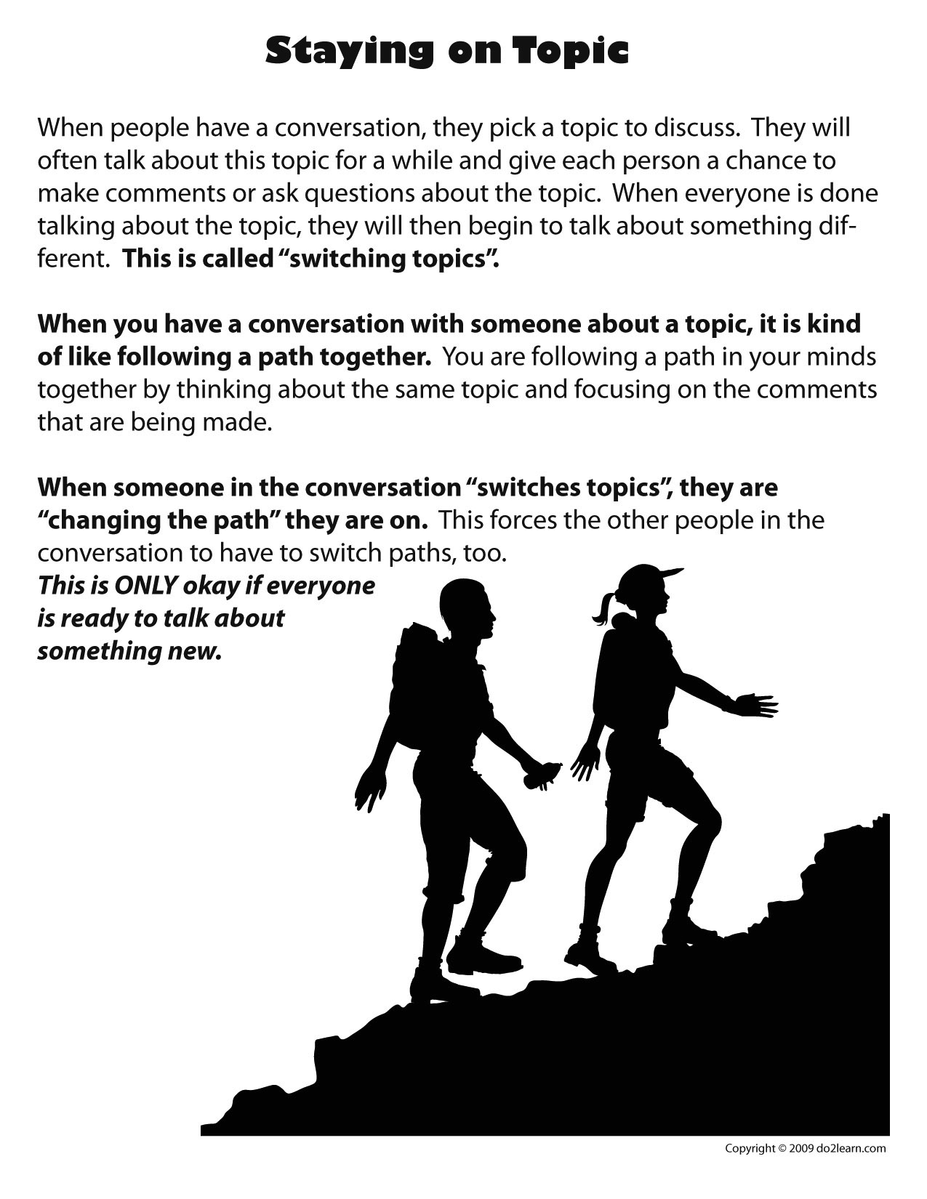

**Listening to Others**

**Source:**

do 2 learn. (2009). *Paying Attention & Listening to Othersc.* Retrieved from

<http://www.do2learn.com/organizationtools/SocialSkillsToolbox/PayingAttention.htm>

**Target population/Issue:**

* Middle School Students with ASD/Social Skills Deficits
* Group Stage-Working

**Outline of the Activity:**

* **Check in**- Share one thing you did this week to move towards achieving your personal social skills goal.
* **Review of norms** **& previous session (& possibly homework)**
  + **Intro**- When you are speaking with another person there are a few ways that you can show them you are interested in the conversation. What are some of these ways? (Write brainstorm out on the board or large paper).
* **Activities**
  + Hand out “Listening to Others” worksheet. Have participants read aloud the skills and brainstorm the purpose (see completed worksheet for example purposes).
  + Model the four skills with a member. Ask partner participant how he/she felt during the exercise. Did she feel heard, ignored, important, etc?
  + Participants practice in pairs demonstrating the four skills. Provide feedback to all groups, noting when a person exemplifies listening skills. (note leader could direct the topic of conversations depending on the stage and needs of the group.)
* **Process Questions**
  + What was is like for you to practice the listening skills?
  + By a show of thumbs (up, down, middle) was this activity easy for you? Up-yes, Down-no, Middle- kind of. [member name] why was this easy/hard? [member name] what part was easy/hard?
  + How did it feel to make eye contact with someone?
  + [participant name] how did it make you feel when your partner commented on what you said?
  + How does this connect to real life social situations?
* **Wrap Up:** Thank members for their participation and engagement
  + Today we discussed how to listen well to others and show them that we are interested and paying attention when they speak. We wrote down the ways we can do this and then we practiced in pairs. (Add session specifics)
  + Optional homework: Practice your listening skills with a peer in English class, note their reaction and come to group ready to share.

**Rationale**

* Young people with ASD have a hard time understanding the implicit rules of communication. By explicitly stating how to actively listen, watching the leader model active listening and then practicing themselves participants will be able to better engage in conversation with others.

**Goals**

* Members will identify and demonstrate at least four ways to show they are actively listening to a person.

Macintosh HD:Users:bailey:Dropbox:ListeningToOthers-blank.pdf

Macintosh HD:Users:bailey:Dropbox:ListeningToOthers.pdf

**Understanding Body Language Part 2**

**Source:** Personal Experience.

**Target population/Issue:**

* Middle School Students with ASD/Social Skills Deficits
* Group Stage-Working (note, this lesson would come after members were introduced to the concept of Theory of Mind. This lesson is the second of two about body language; the first introduces the concept of body language and reviews common body language.)

**Outline of the Activity:**

* **Check in**- When did you feel happy this past week?
* **Review of norms** **& previous session** **(& possibly homework)**
* **Activities**
  + Watch a short video clip like <http://www.youtube.com/watch?v=poSL6uhFmTY> without the sound and ask members what each character is feeling (how do they know that?). Then have members make inferences about *why* the character is feeling that way. Re-watch video with sound and talk about how accurate the inferences were.
  + I am going to stay an emotion and I want everyone in the group to make the matching face and body language. Here is an example-leader models sad body language (If group needs external incentive provide stickers or candy for the most authentic face)
    - Emotions: Mad, Sad, Happy, Frustrated, Surprised, Scared
    - Comment on the correct body language “I see that [member] is frowning, this lets me know that he is sad” or ask others “What about [member]’s body language lets me know she is excited?”
      * If needed have members fill in a list of emotion corresponding body language i.e. Angry looks like… [scrunchy eyebrows, tight lips, balled fists, etc] See handout below
    - For each emotion ask one participant to explain why he/she might feel that way. Example: [member name] what makes you feel angry? If that event makes other members feel that way have them do “spirit fingers” to show that they agree. If not everyone agrees ask another members how this event would make them feel. This way members are reminded that the same events can make people feel differently (Theory of Mind).
* **Process Questions**
  + What was the first activity like for you?
  + By a show of thumbs (up, down, middle) was the second activity easy for you? Up-yes, Down-no, Middle- kind of. [member name] why was this easy/hard? [member name] what part was easy/hard?
  + How did it feel to not be able to hear the people on the video?
  + How does it make you feel to know other people have different reactions to the same events?
  + How does this connect to real life social situations?
* **Wrap Up:** Thank members for their participation and engagement
  + Today we learned more about how people’s bodies and faces express how they are feeling. We also discussed that people can respond to the same event with different emotions. These are important things to keep in mind when we talk to others. –Add session specific themes/points.
  + Optional Homework: Ask three people in your life what makes them happy, see if they are the same or different. Be ready to discuss next week.

**Rationale**

* Youth with ASD have a difficult time interpreting body language, especially for subtle feelings like frustrated or surprised (see literature review or DSM 5). By practicing emotions and the corresponding body language members will be able to recognize important body language cues.
* Youth with ASD also have difficulty with the concept of Theory of Mind, or the fact that others do not think or feel the same way they do. This can lead to members making incorrect assumptions about the feelings or thoughts of other people. By explaining TOM in a concrete way, using members’ own experiences and emotions this group activity will demonstrate the concept of TOM in a developmentally appropriate way.

**Goals**

* Participants will be able to describe and identify body language for at least 5 common emotions.
* Participants will be able to articulate the concept of theory of mind in their own words.

Name ________________________

**Body Language and Emotions**

1. Mad looks like…
   1. Some reasons people would be mad are…
2. Sad looks like…
   1. Some reasons people would be sad are…
3. Happy looks like…
   1. Some reasons people would be happy are…
4. Frustrated looks like…
   1. Some reasons people would be frustrated are…
5. Surprised looks like…
   1. Some reasons people would be surprised are…
6. Scared looks like…
   1. Some reasons people would be scared are…

**Termination**

**Source:**

Smead, R. (2000). *Skills for Living: Group Counseling Activities for Young Adolescents.* Champaign, IL: Research Press.

**Target population/Issue:**

* Middle School Students with ASD/Social Skills Deficits
* Group Stage-Termination

**Outline of the Activity:**

* **Check in**- Feelings chart, circle the face that best expresses how you feel right now
* **Review of norms** **& previous session**
* **Introduction**
  + “Sometimes it is very hard to say good-bye, especially when the person or persons mean a lot to you at that time. During the last several weeks we have shared many personal, private and painful things about ourselves and hopefully this makes us feel really close. The closer you feel, the harder it is to say good-bye. But this isn’t good-bye forever! It is good-bye for the group meetings each week as we know it. Some times it feels a little lonely when group ends.” (Smead, 2000, p 54). Today we are going to remember and process some of our favorite moments in group, this will help us feel better about ending group. But remember we can all continue to work on our personal growth and be friends outside of group!
* **Activities**
  + Remembering group. Have group members fill out “Remember Group” worksheet and then share as a group. Discuss member’s answers.
  + Transition Object (Kim, 2013, Personal Communication) - CD with two songs from each member that represent what group means to them. Explain: This CD represents what group means to each one of us and together it represents what group meant to all of us. When you listen to this CD (when you transfer it into MP3s) you will remember all the good things that happened in group and the growth that happened here.
  + Ice cream party!
* **Process Questions** (can occur during ice cream party)
  + What was being part of group like for you?
  + On a scale from 1 to 10, 1 being no risk and 10 being a lot how much risk did you take in group?
  + How does it feel to be done with group?
  + How will you use what you learned in group in the future?
  + “How was it for you today when we reviewed all the sessions and you shared moments and talked about how events changed you? How were you feeling?” (Smead, 2000, p. 81)
* **Wrap up**
  + Thank participants for sharing and allowing you to be a part of their group. Example “You have taken some big steps toward improving your relationships, and I believe in each one of you. You have shown me you all have the ability to make changes for the better. I have a great deal of hope and confidence that each of you will continue to take the risks to grow as beautiful, kind, and loving person.” (Smead, 2000, p. 82).

**Rationale**

* Termination is hard for any group. However, students with ASD rely on repetition and predictability more than their typically developing peers. As such it is very important to dedicate time to process the end of group.

**Goals**

* To review what happened in group, how group impacts members now, and how it will help them in the future.
* To provide closure for members.

**Remembering Group**

1. Write about one group activity or session that was particularly hard for you and why.

2. Write about your favorite group activity or session. Explain why it was your favorite.

3. Write about one skill you think you have improved because of group. What or who helped you improve?

4. How has group helped you move towards your personal goal (established in group session 5)?

Appendix B

**Sample Exit Interview: Reciprocal conversation and staying on topic**

Interviewer- Imagine I am a kid from group and I come up to you a start talking about the movie 1. I saw last week. I will start. “Hey ______. Guess what movie I saw this weekend?”

2. Student Response: (preferred responses: *guesses a current movie.* Says-I don't know what movie did you see?)

3. Interviewer-I saw Iron Man 2.

4. Student Response: (preferred responses: Oh I saw that movie too. How did you like it? or Who did you go with?)

5. Interviewer-I liked it a lot my favorite part was when the house fell into the water. What about you?

6. Student Response: (preferred responses: I liked that part too. Or My favorite part was____. Did you like that part too?)

*At this point the student has met the goal*

Appendix C

**Post Group Survey-Student**

*Body Language and Emotions* (modified from 2010 Vanderbilt TRIAD)

Directions: In the space underneath the picture write how each child feels.

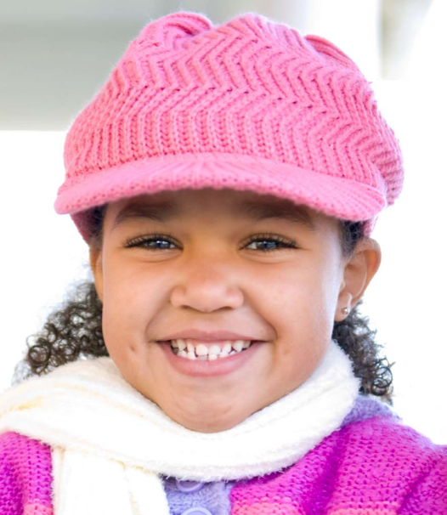

____________________



________________________



________________________

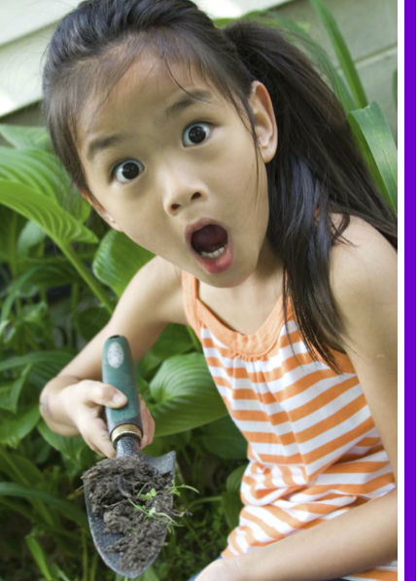

________________________

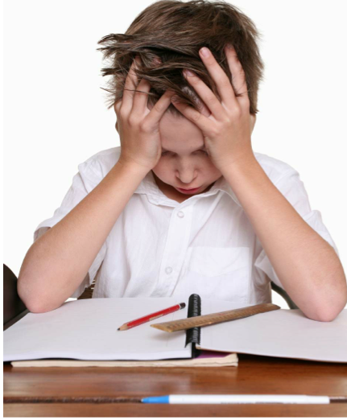

________________________

Rewrite the following idiomatic phrases in your own words.

1. Joelle said she didn’t eat the cookies but he had crumbs on his shirt. She was caught red handed.

A: ______________________(answer: she was caught doing something wrong)

2. I am so scared of public speaking and I have to make a class presentation. I have butterflies in my stomach.

A: ______________________(answer: I am nervous and my stomach feels odd)

3. He had gotten attached to his neighbor’s dog but now they were moving away. His heart was broken.

A: ______________________(answer: he was very sad).

4. I saw you in the lunch line yesterday but you didn’t say hi. You gave me the cold shoulder

A: ______________________(answer: you ignored me)

5. I am really good at math and we only had 3 problems for homework. It was a piece of cake

A: ______________________(answer: it was really easy)

List 5 qualities of being a good friend

1.

2.

3.

4.

5.

Appendix D

Macintosh HD:Users:bailey:Dropbox:TRIAD Teacher survey.pdf

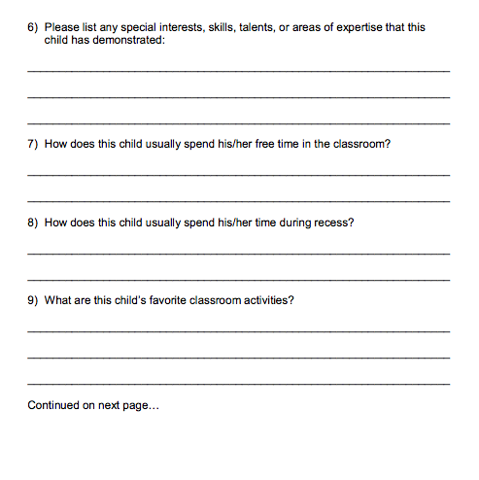

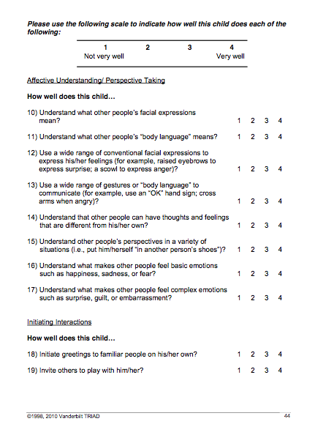

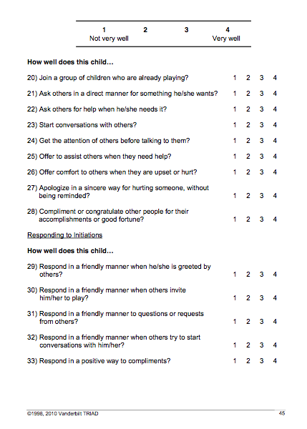

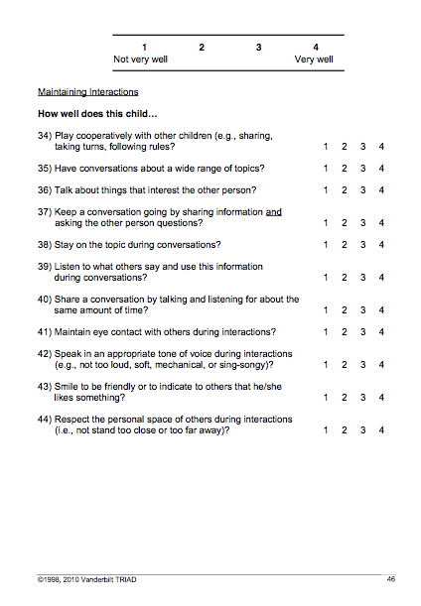

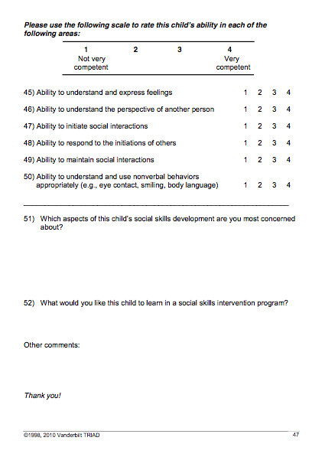*For the post survey questions 51 will be changed to: What aspects of this child’s social skills development have most improved?

Appendix E

**Possible questions for post group Parent Interview** (modified from TRIAD Parent Survey)

* Has the amount of times per week your child invites friends over increased since the beginning of group?
* Has your child expressed interest in something new (activity/movie/hobby) since the beginning of group?
* Is your child more interested in spending time with peers?
* Is your child more interested in making new friends?
* Have you noticed an increase in your child’s ability to understand and express feelings?
  + How has this manifested itself?
* Have you noticed an increase in your child’s ability to understand the perspective of another person?
  + How has this manifested itself?
* Have you noticed an increase in your child’s ability to initiate social interactions?
  + How has this manifested itself?
* Have you noticed an increase in your child’s ability to respond to others appropriately.
  + How has this manifested itself?
* Have you noticed an increase in your child’s ability to understand and use nonverbal behaviors appropriately?
  + How has this manifested itself?
* Any other positive changes you have noticed in your child since the beginning of group?

1. PPC format-“Students report on problems experienced during the past day. They then talk together to award the session to one student. The students then help the student who has the session understand and work toward a resolution of the problems identified” (Longhurst et al., 2010).